**1-Home page-Home page of Duke books store**

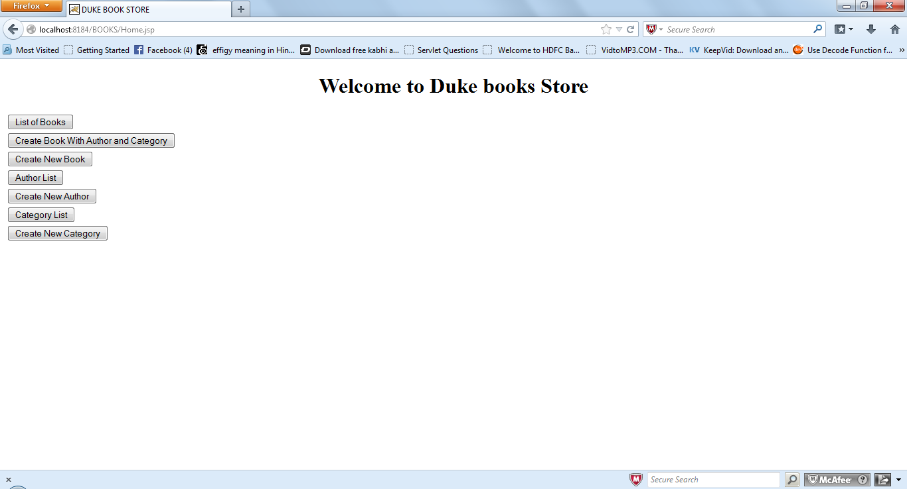

**2-Click on the List of Books-**

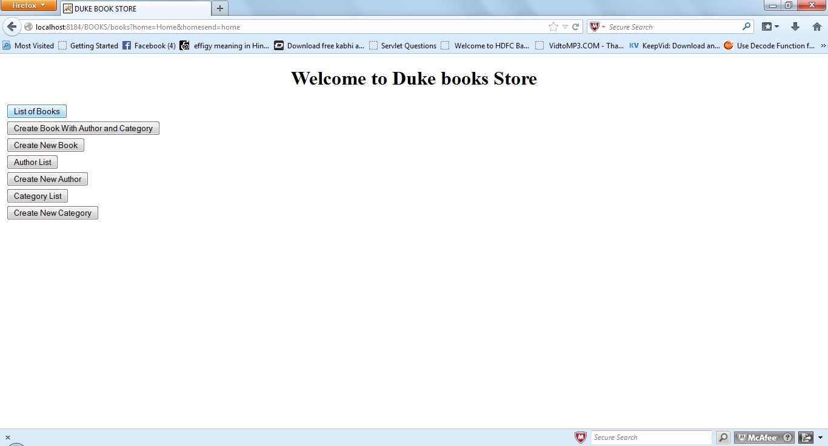

3-If the Book list is not available it will not show the list of books and it force to create a books as well as author and category. So on click on button it will redirect to create a book as well as author and category.

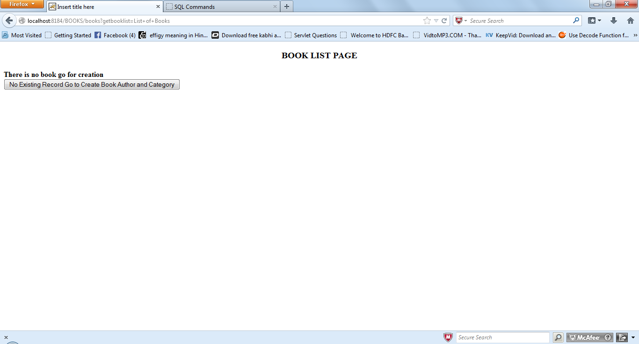

4-Create Book page-Here the detail will be filled by the user .

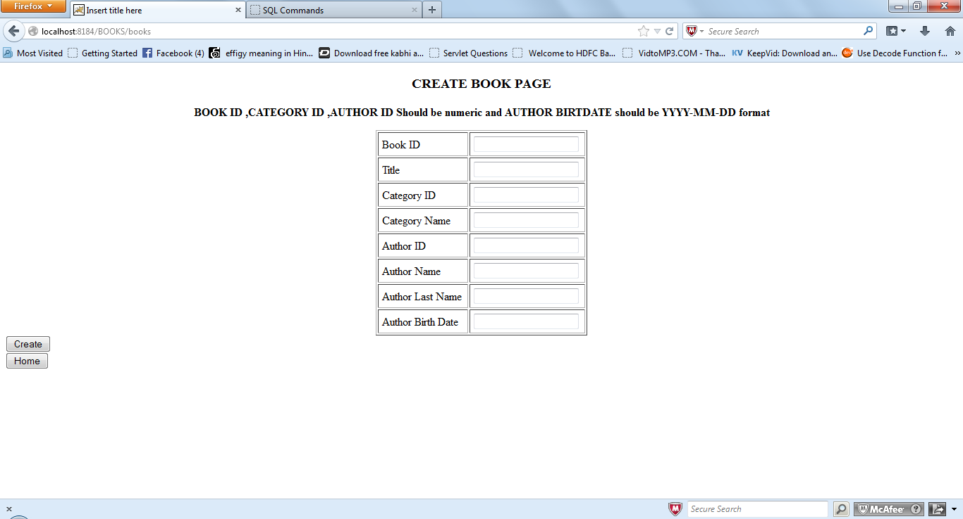

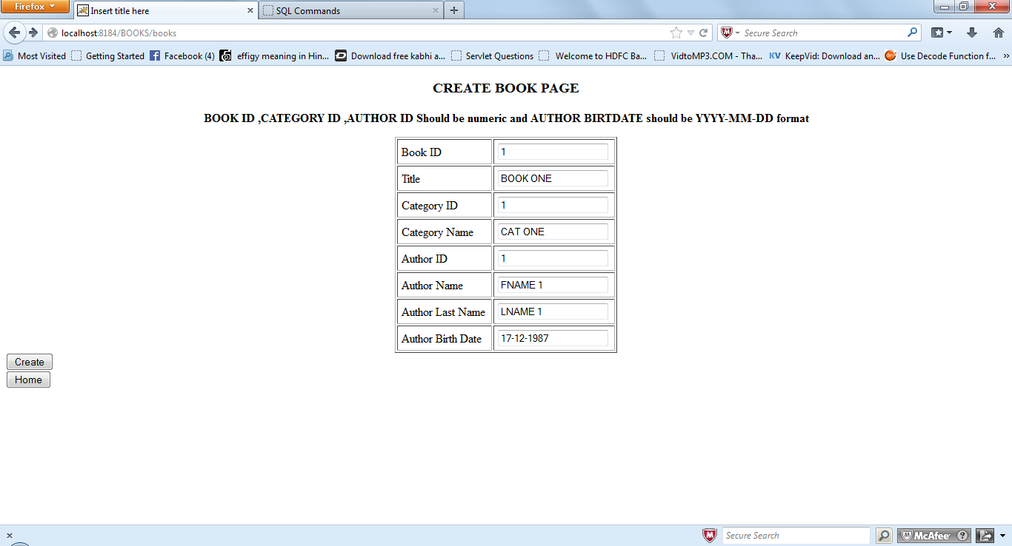

5-if all the detail will be inserted then it shows the message “DATA IS INSERTED IN TABLE”.

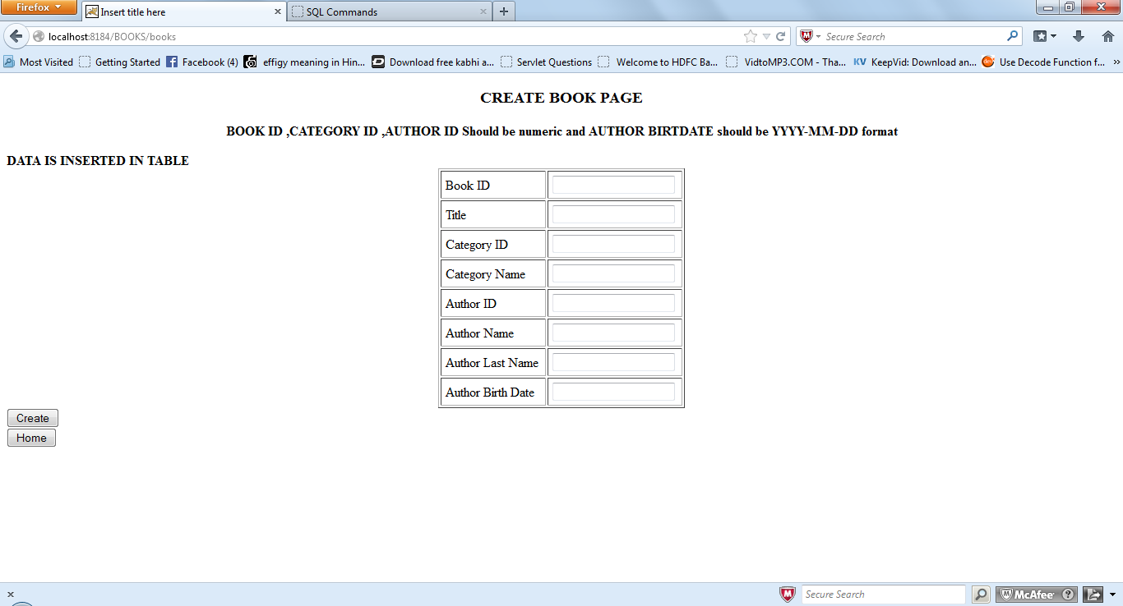

6- click on home button it will redirect to home page which have menu.

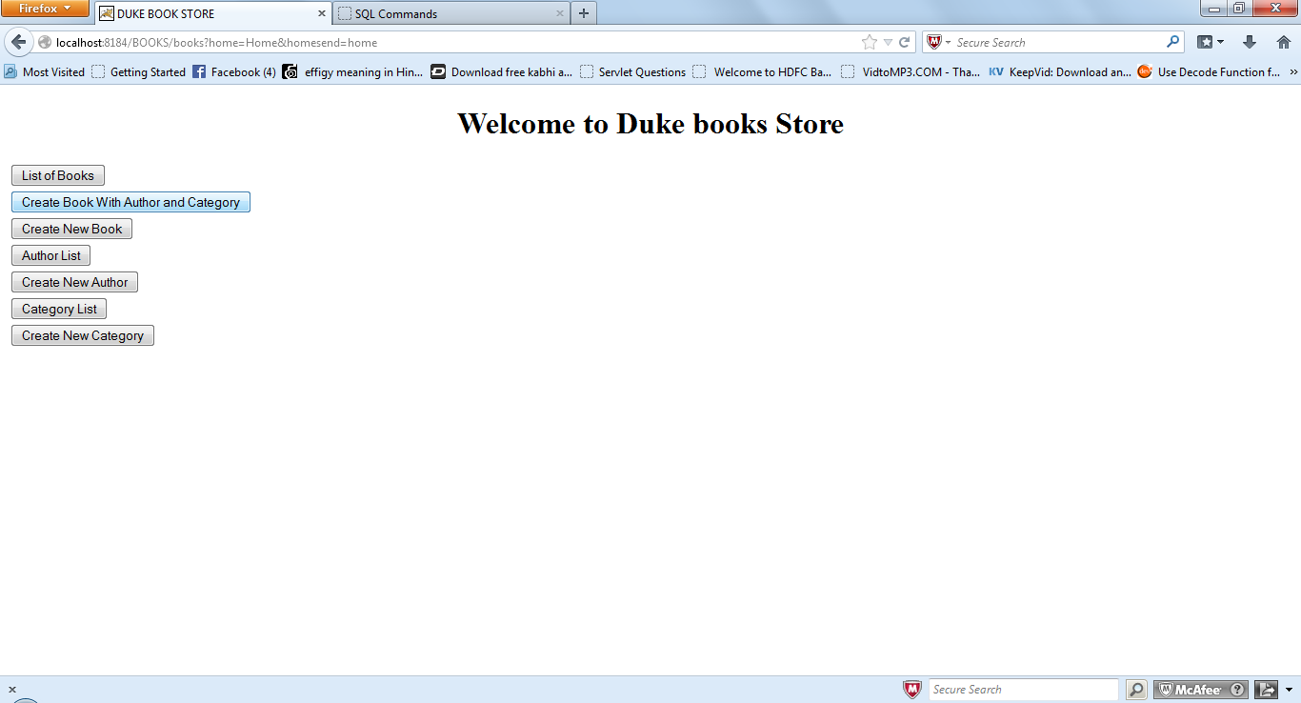

7-If user wants to create a book with existing category and author then user clicks on the “Create New Book” button.

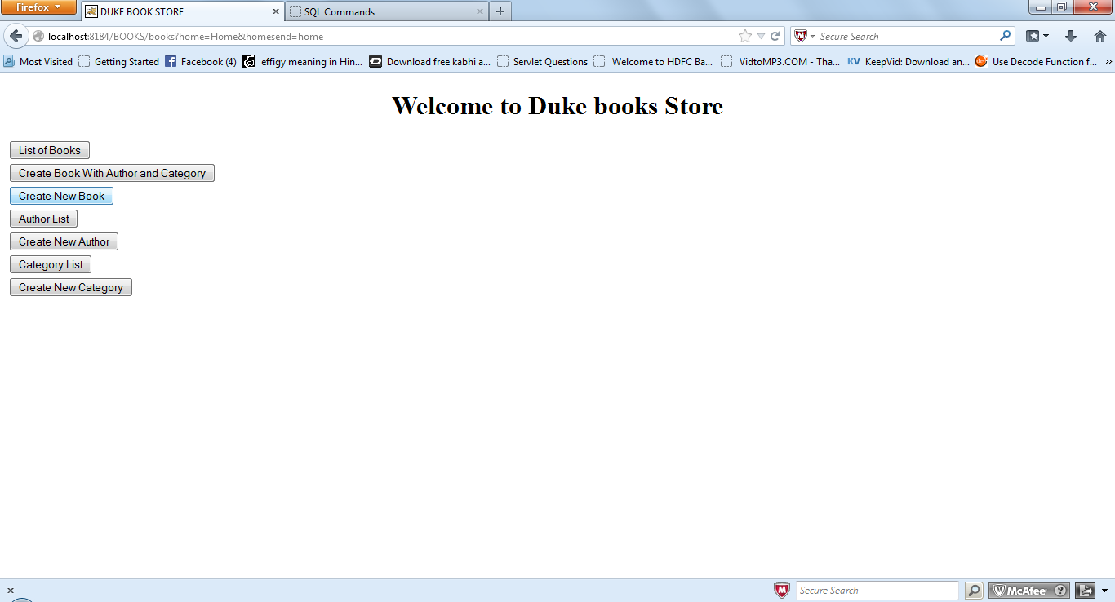

8-This is the page which have the existing category id and author id in the drop down .user fill the detail and then will create the records.

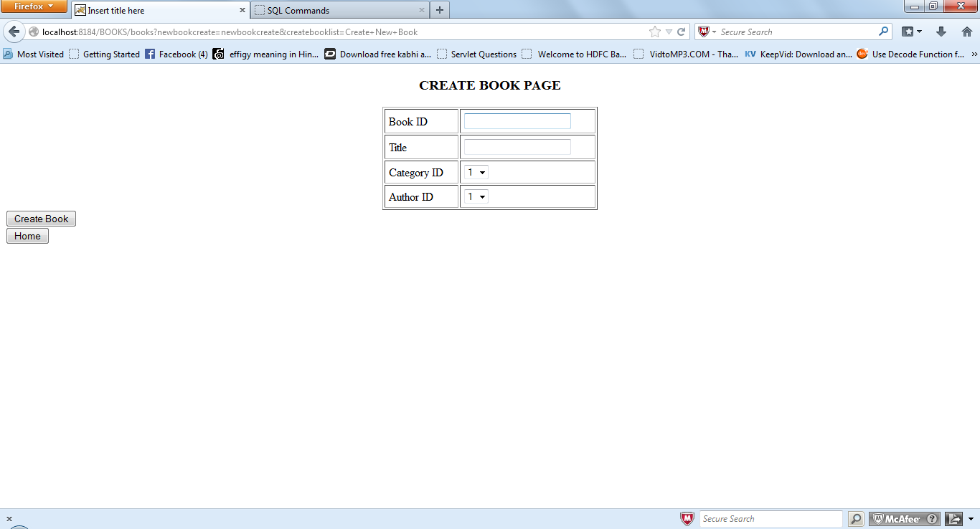

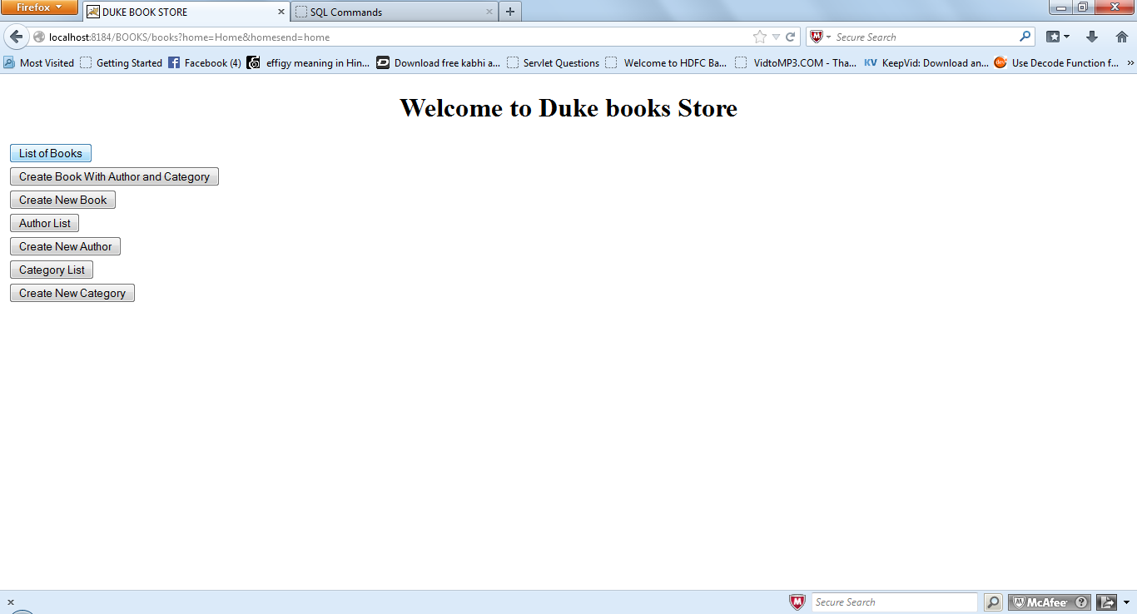

9-user click on the List of books then it will shows the list of book available.

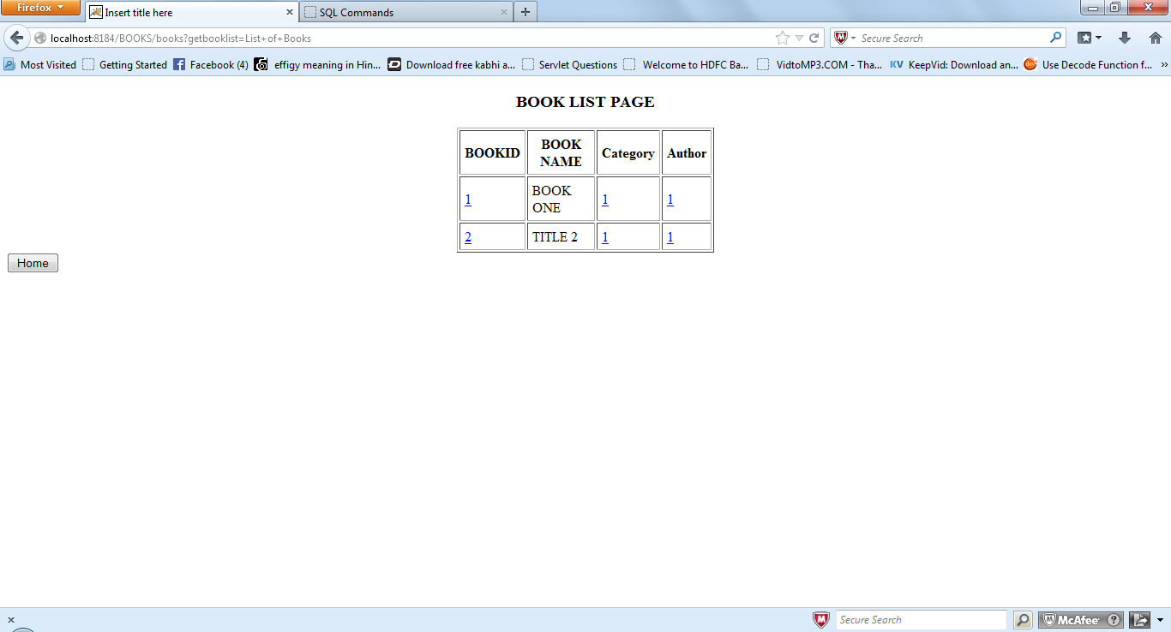

Click on the Book id it will redirect to the full books detail.

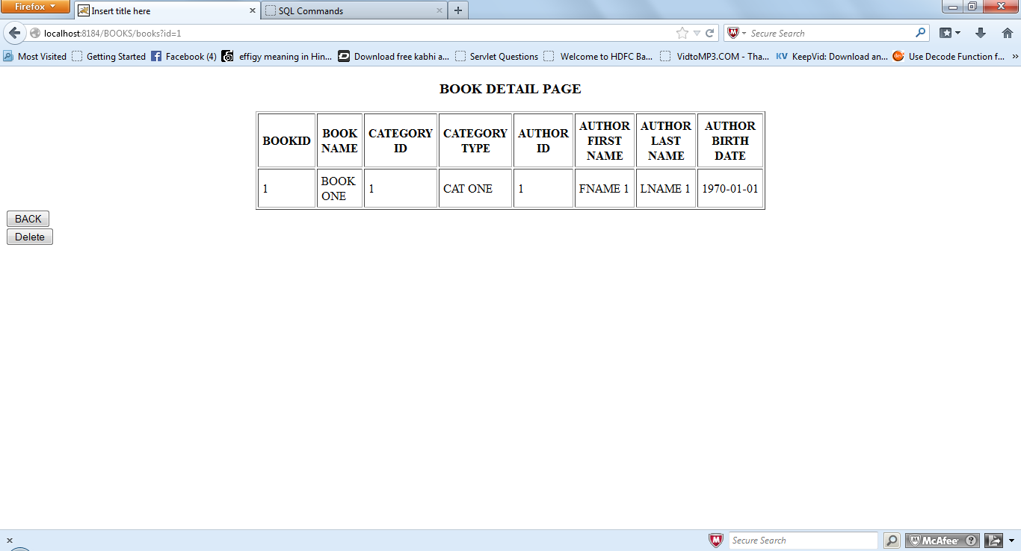

If user wants to delete the record click on the delete button then the record will be deleted. If user want to back the book list page then click on the back button then it will be redirect to the List of Books page.

If user want to book id detail then click on the below book id data column.

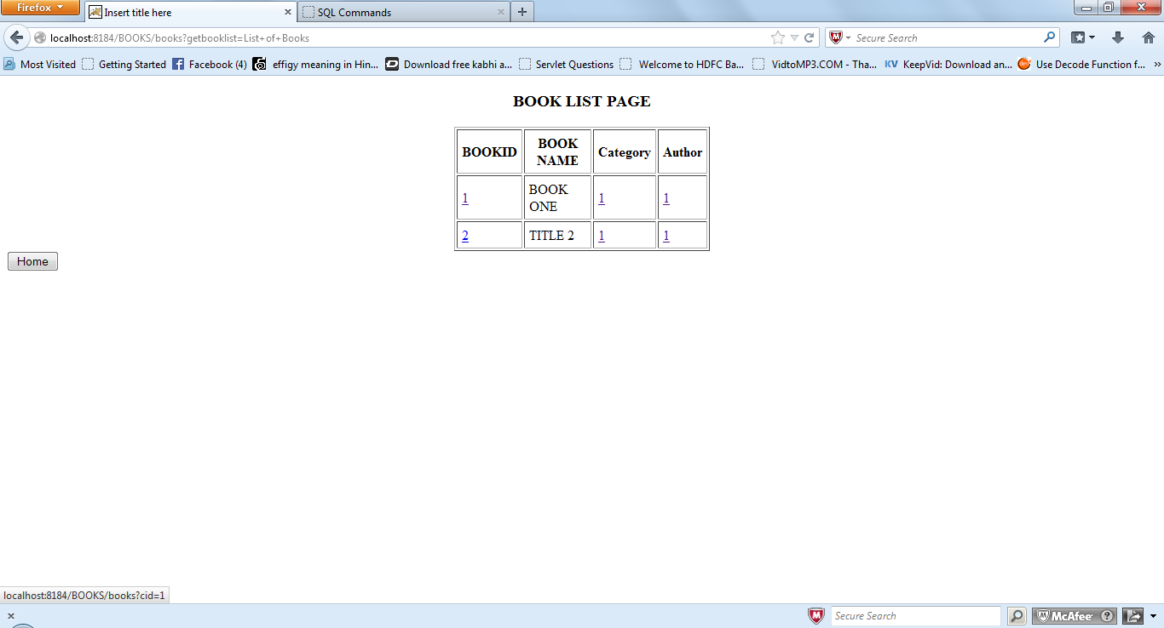

Then below page will be display with specific category.

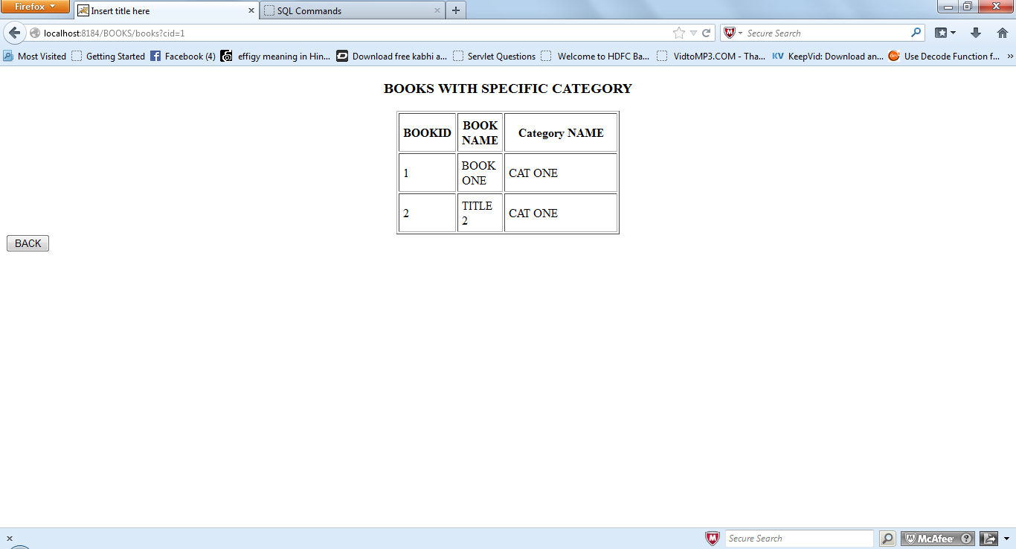

Same if user clicks on the author id data then it will redirected to the specific author detail.

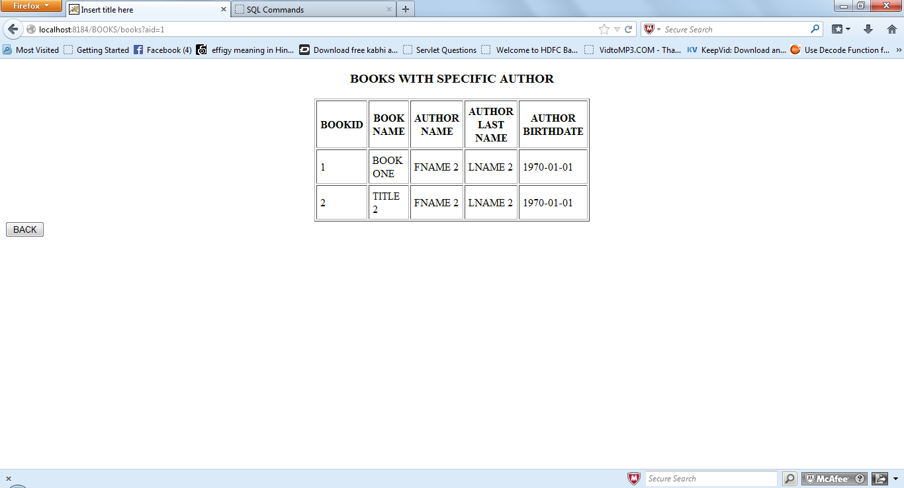

Click on back button then will be redirected to the book list page.

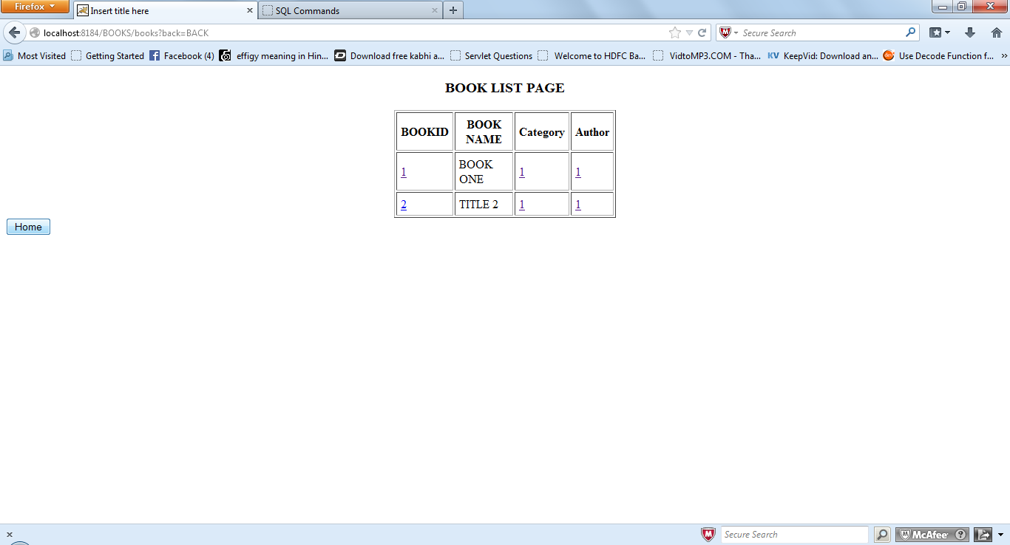

Click on home button then again it will redirected to the home page .Click on the Create a New Author Link. Then it will redirected to the Create a New Author page.

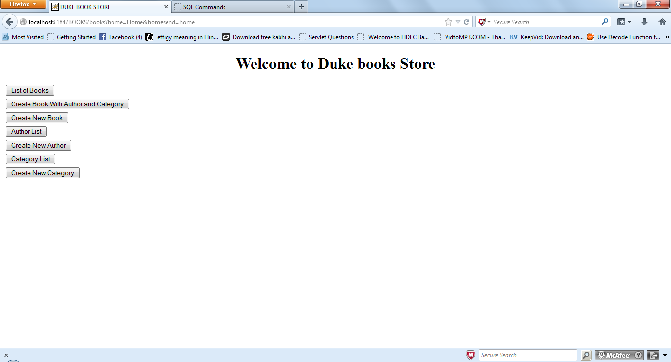

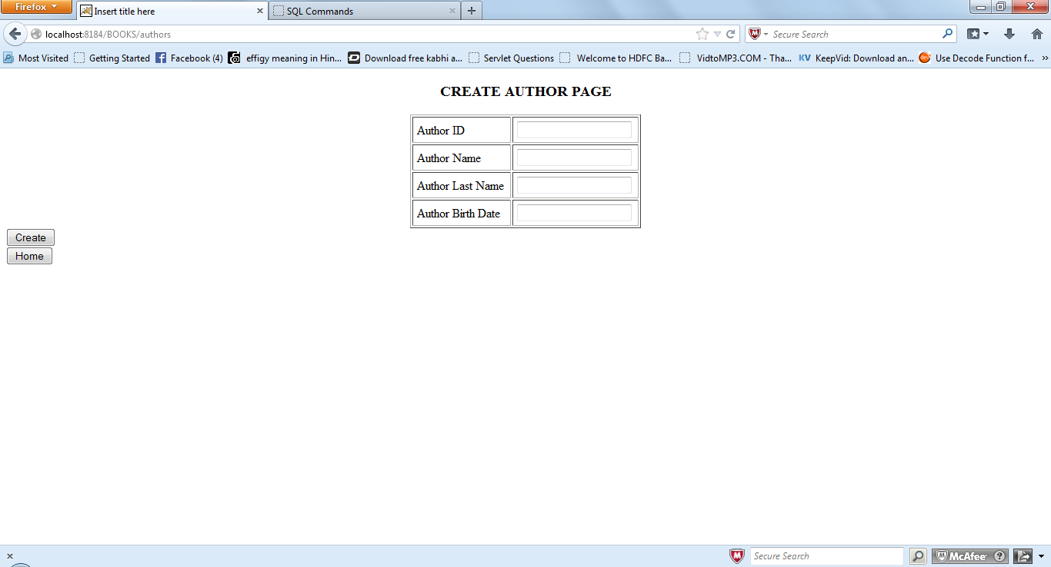

User insert the data as need to create the author.

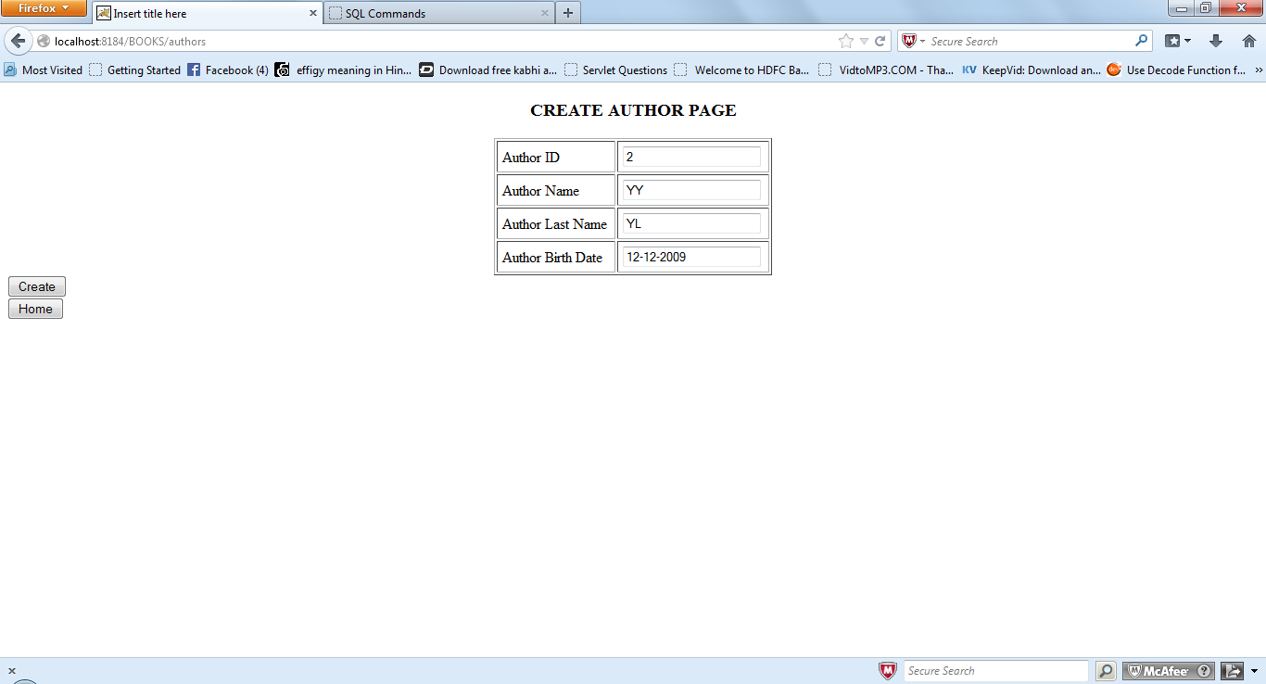

Click on the create then data will be inserted and after insertion message will be shown.

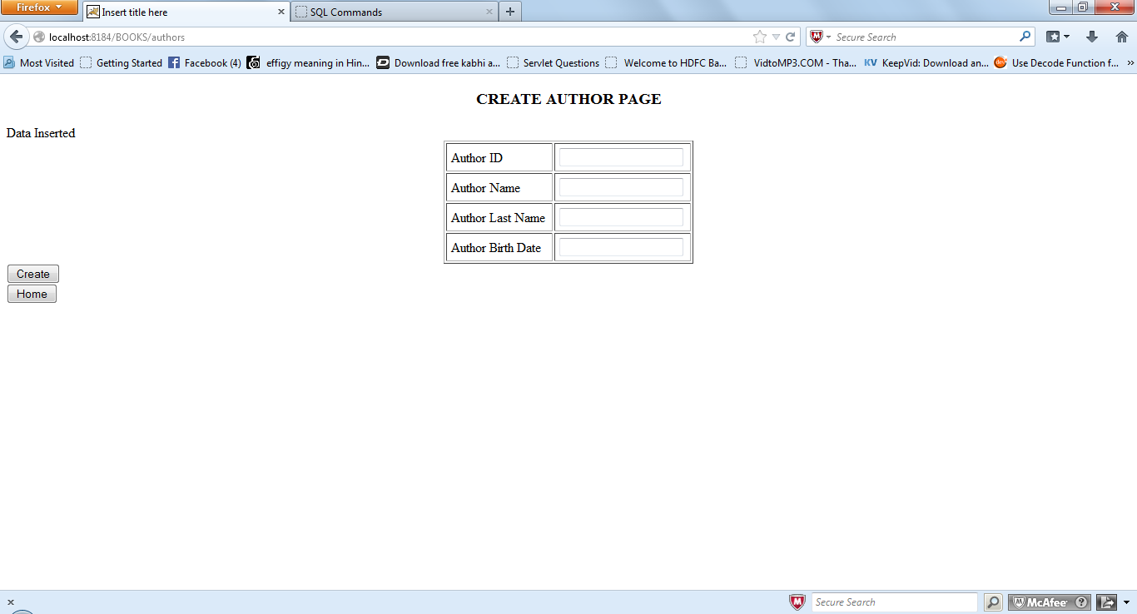

Click on the home button then it will be redirected to the home page.

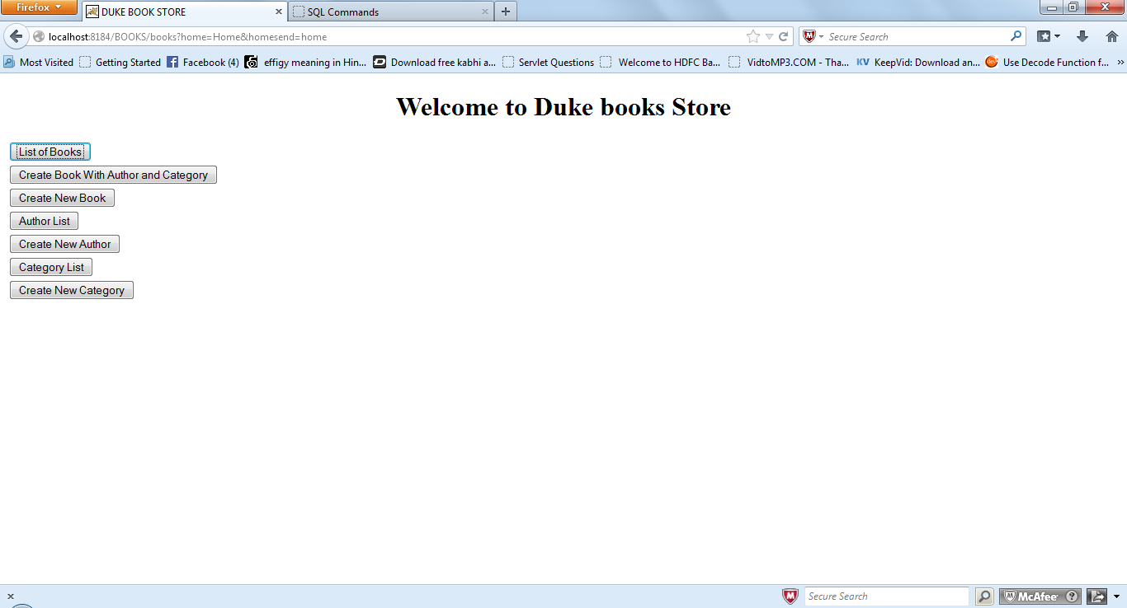

User clicks on the Author List button then it will be redirected to the Author list page.

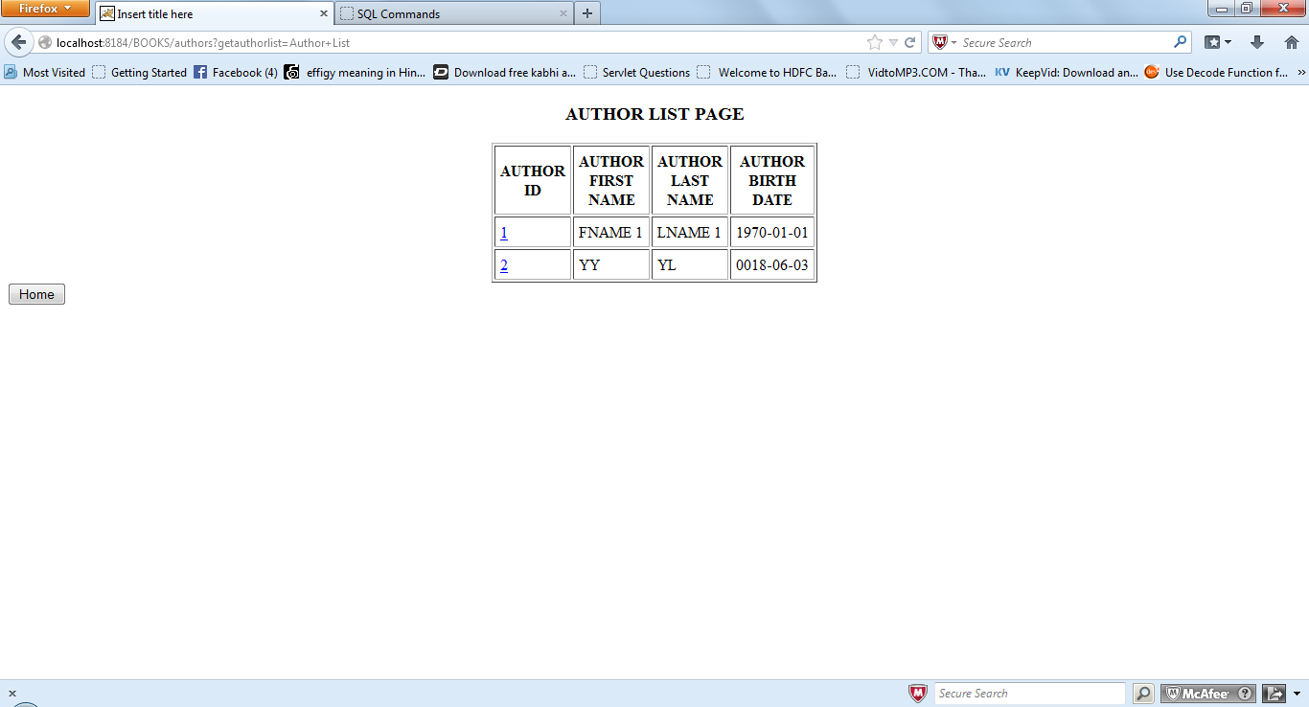

Click on the Author id column it will be redirect to the Author detail page with respect to the specific id.

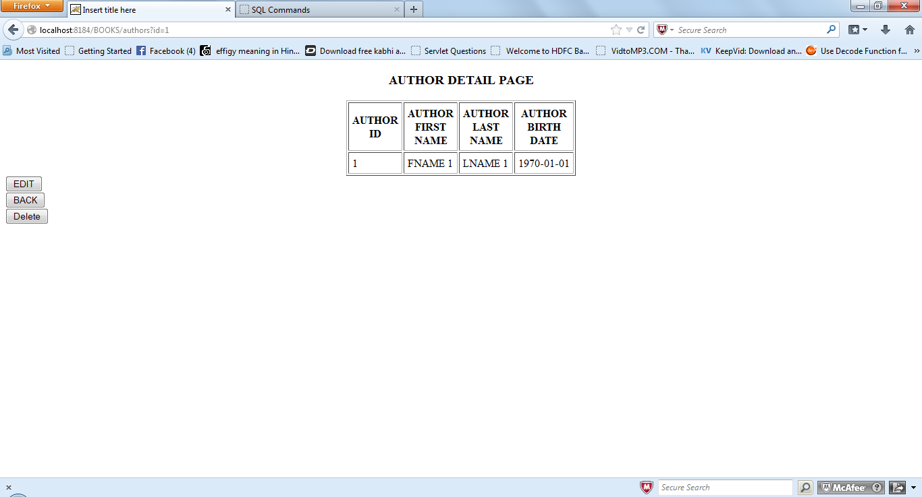

If user wants to edit then click on the edit button ,if user want to delete this particular record then it will click on the delete button ,if user wants to the back button then it will redirect to the Author list page.

If user click on the edit button then click on the edit then it will shown the below page which have auto populate the existing record with respect to the specific id .Author id row is readable mode user cannot change it because it is primary key and uses books table as foreign key.

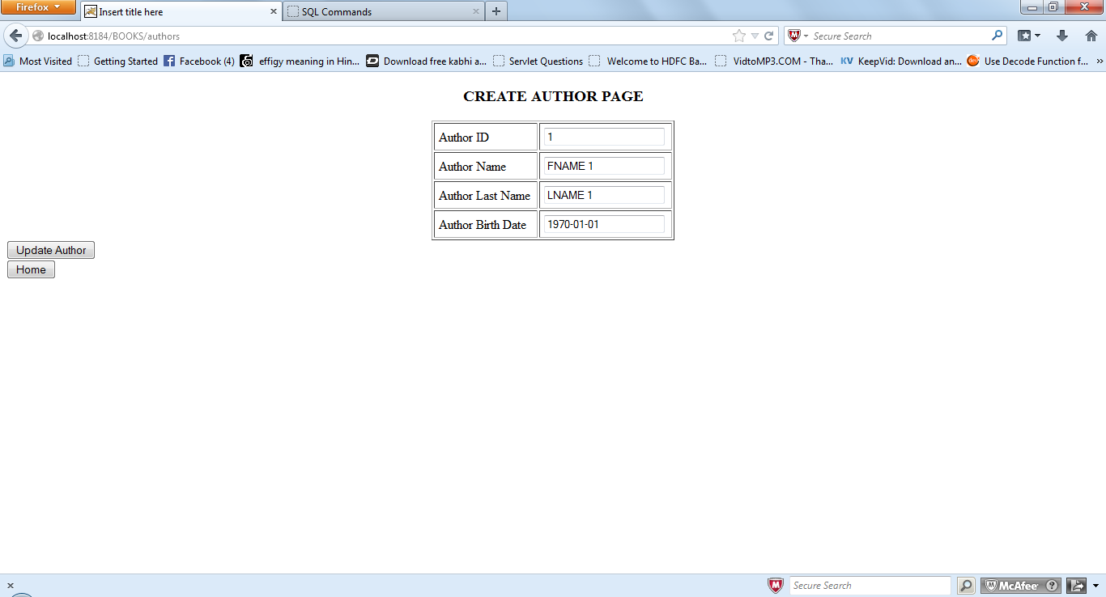

After changing the value in author name author last name and birthday and click on the Update Author it will be redirected to the acknowledgment page.

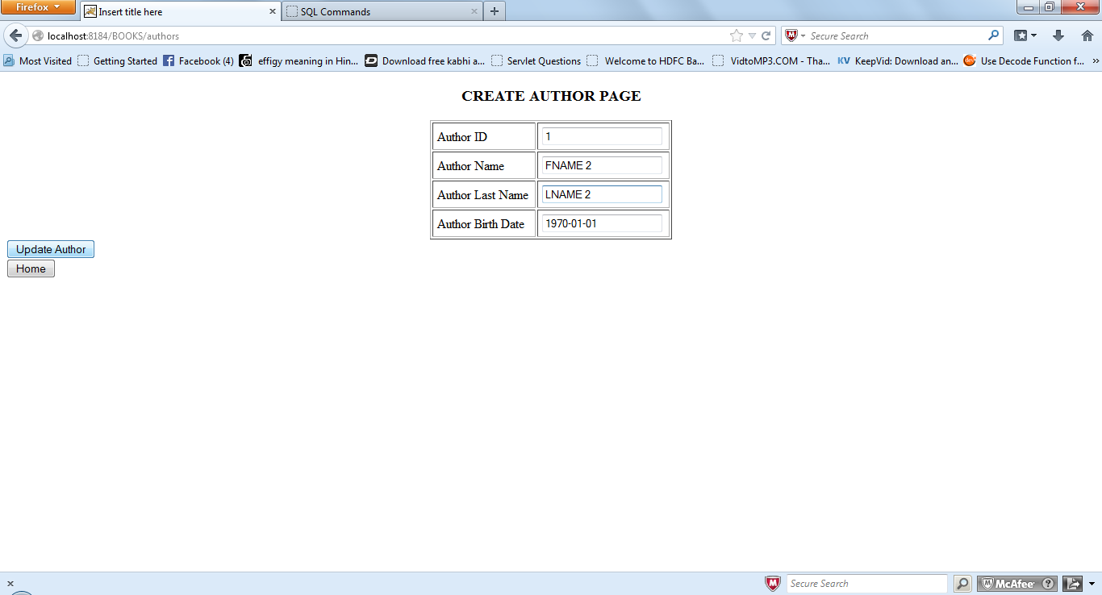

Click on the Go to Author list button back to the Author list page.

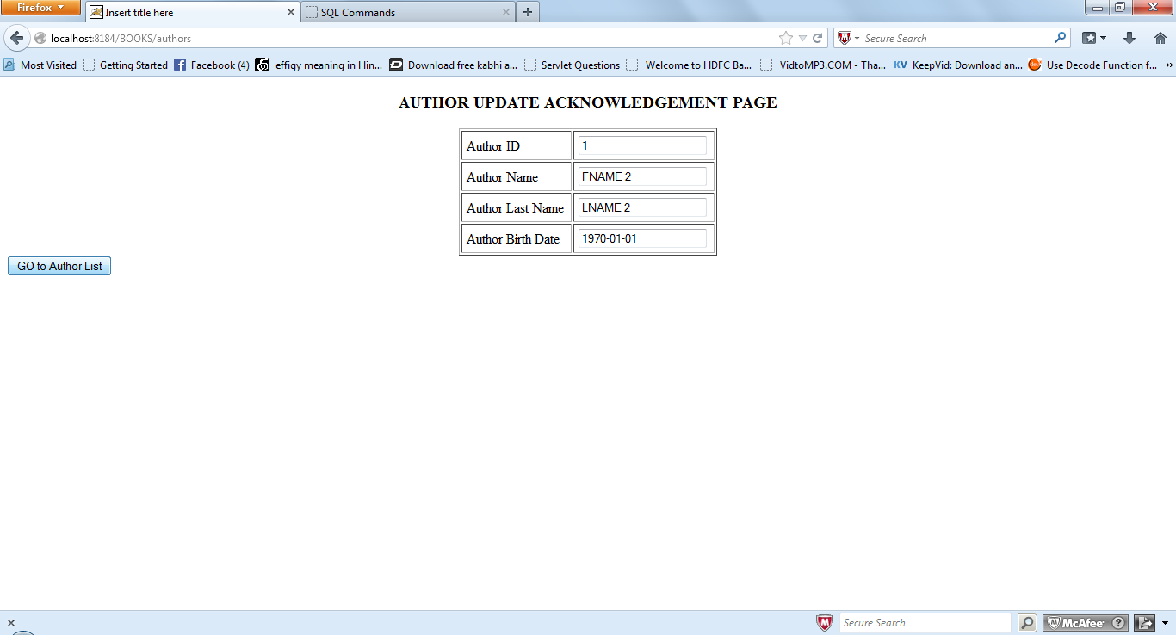

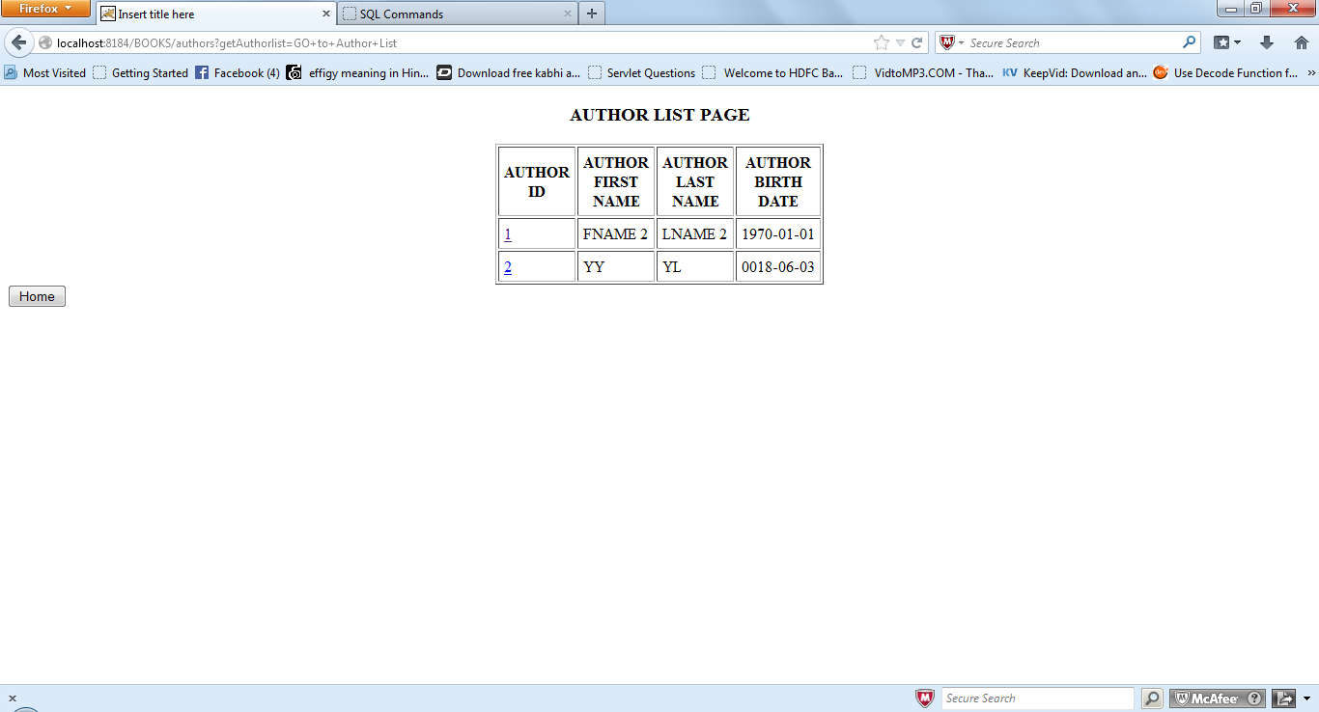

Click on the home button it will be redirected to the home page.



Click on the Category List button then it will be redirected to the Category List page.

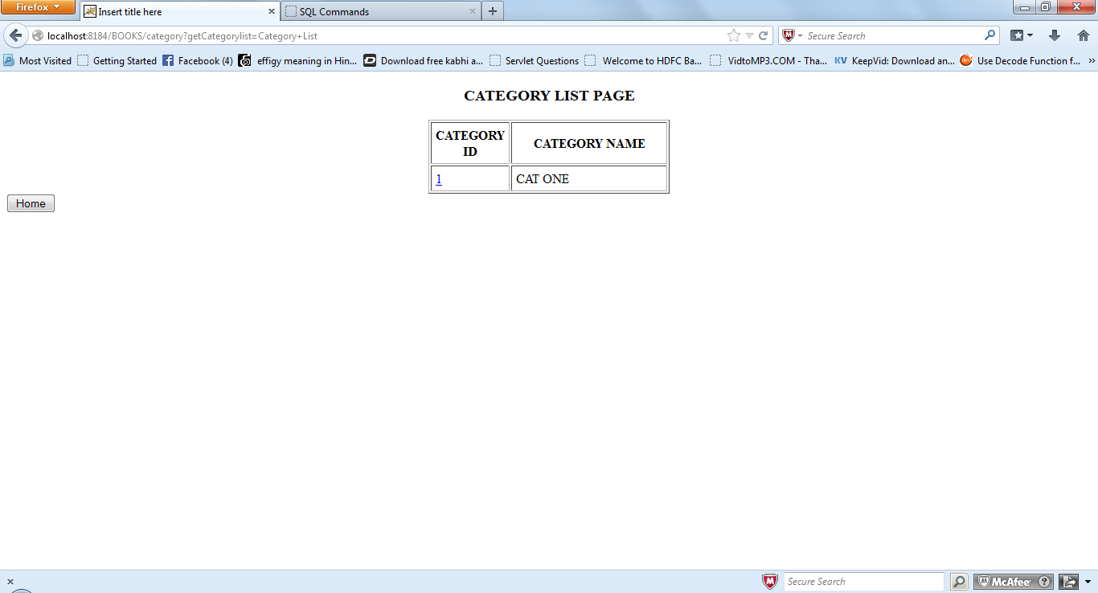

Click on the Category id column data then it will be redirected to the category detail page with specific id data.

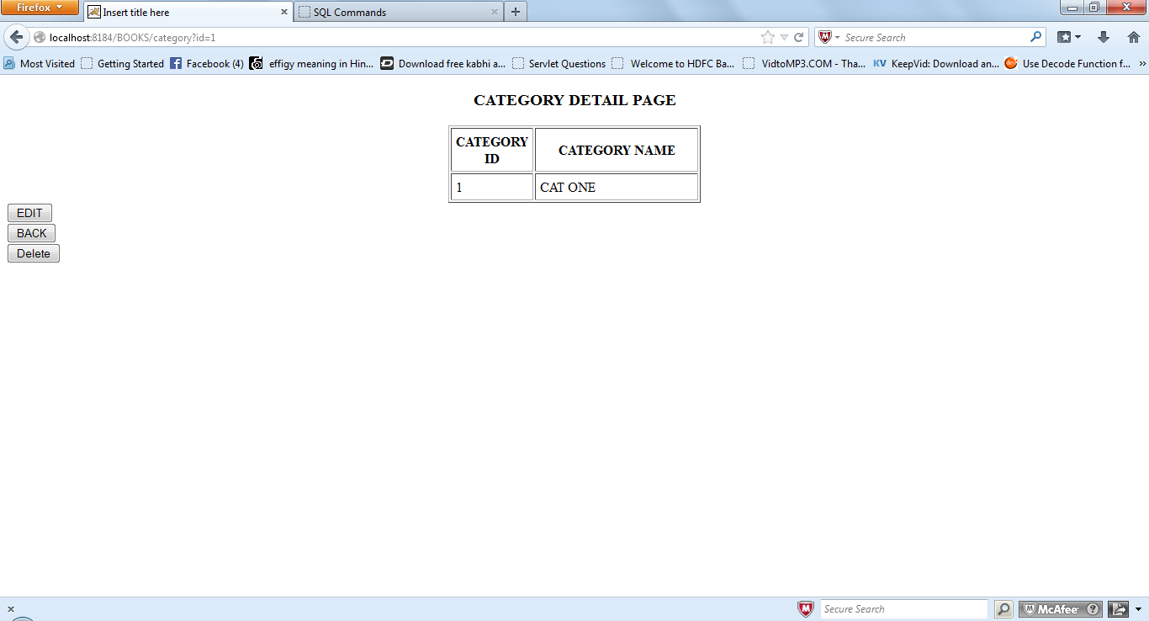

Click on EDIT button it will allow to edit the existing record. Click on the back button it will be send to the Category list page .click on the delete button it will delete the record with respect to the id.

Click on edit then it will shows the below page which having the auto populated data.

Category id row having the readable data.

Update the value in category name.

Click on the update Category.

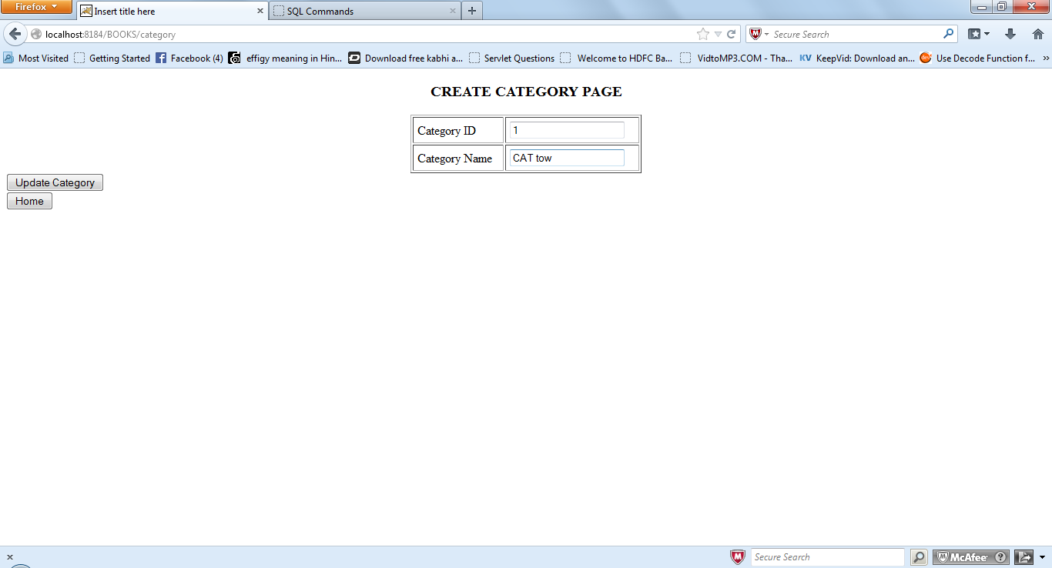

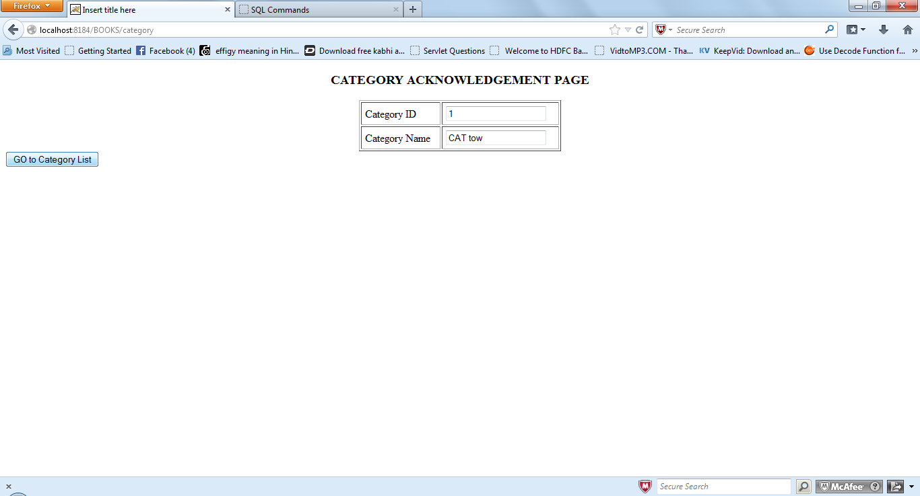

Click on the go to Category List .

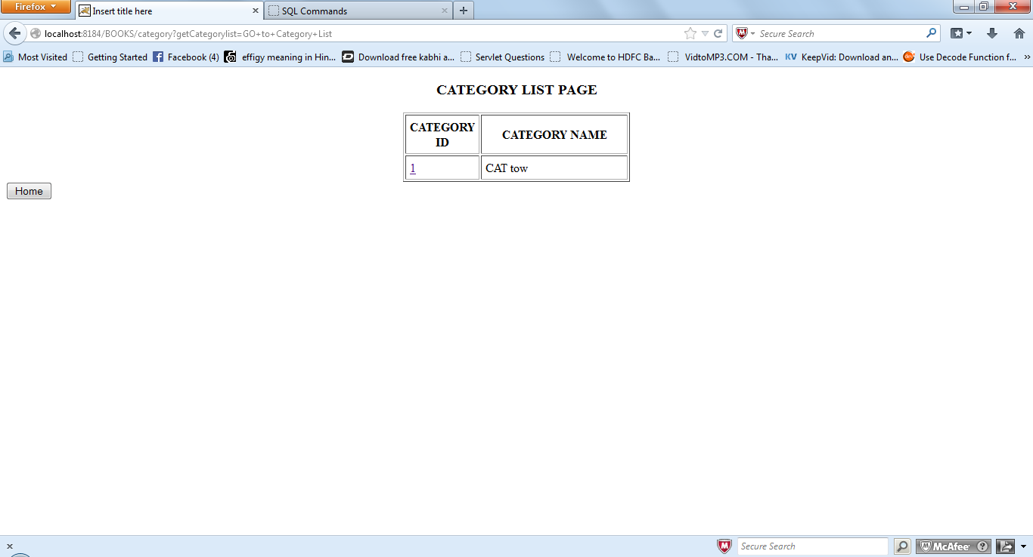



Click on the Create New Category link then it will redirected to the Create a new category jsp.

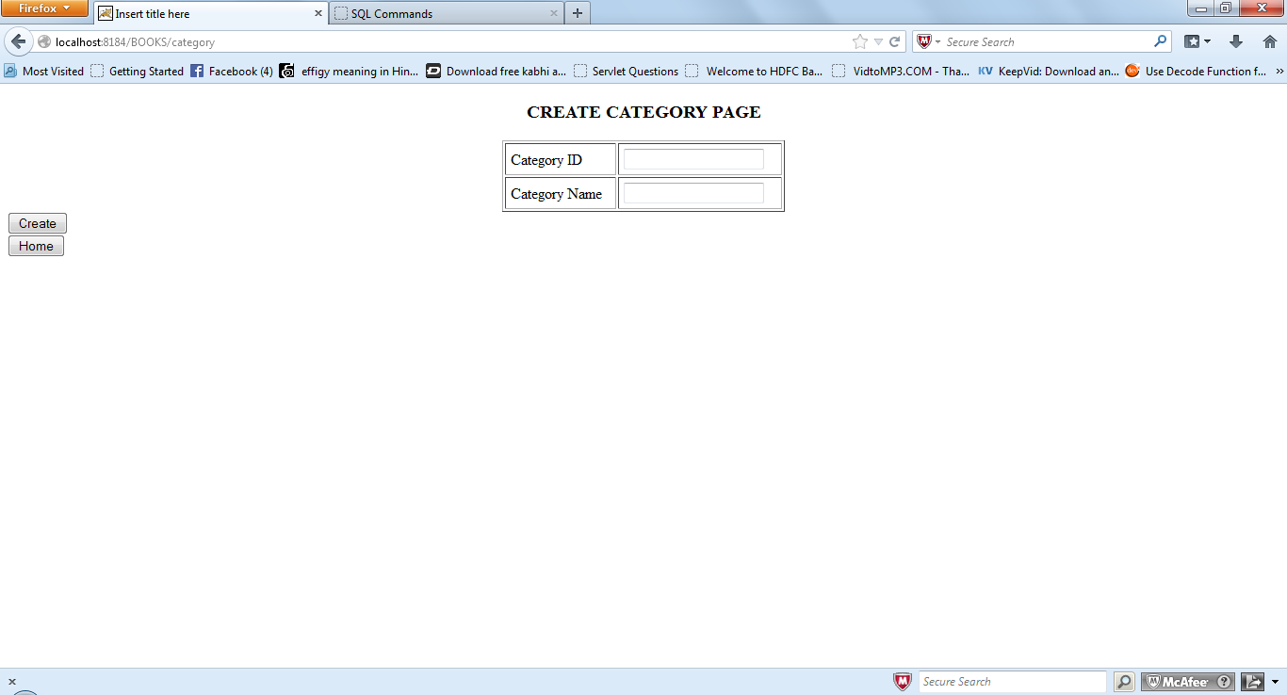

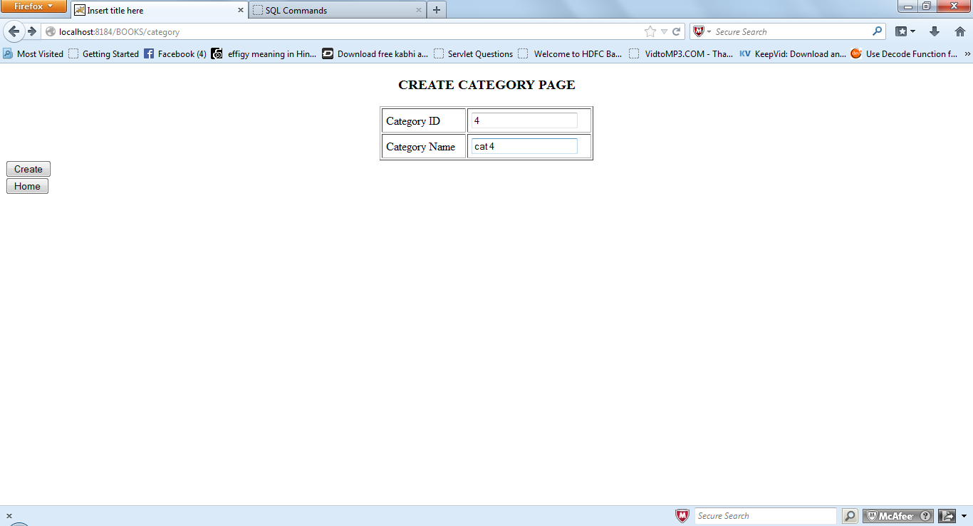

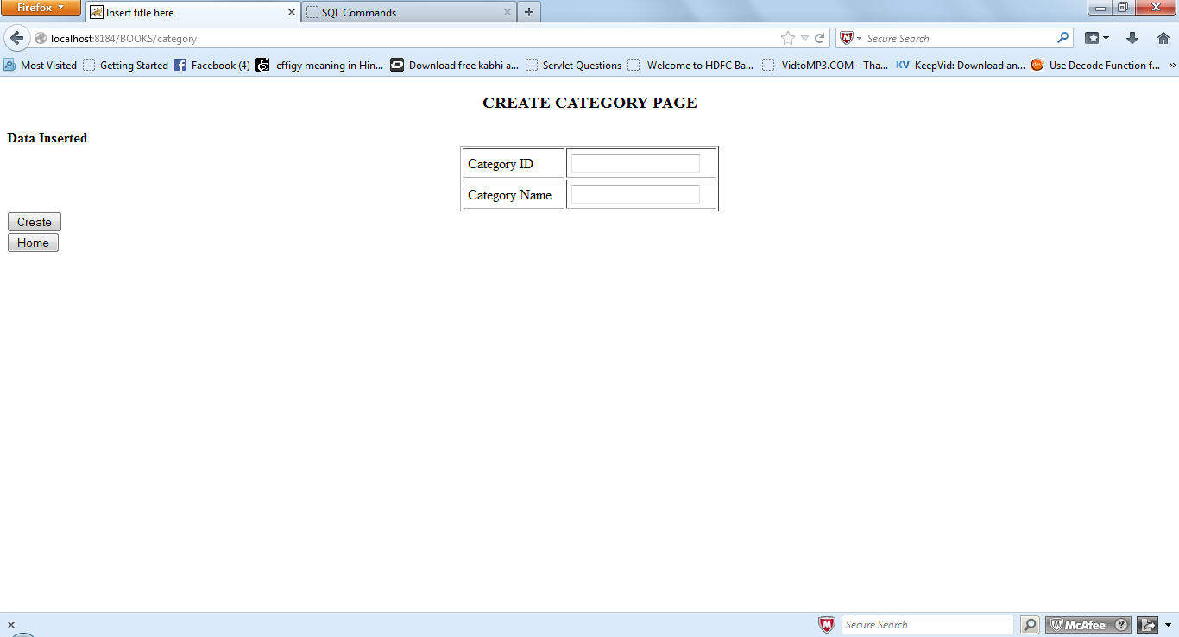

If user enter the category id which is already exist then it will shows the error message,Category id already exist please enter different one.Same thing is applicable with other jsp.

